Pac-Man

In this project you will create a Pac-Man game in Scratch that is able to learn from how you play.

You won’t give it instructions for how to play, or tell it what the objective or rules of the game are.

Instead, you’ll show it examples of you playing the game.

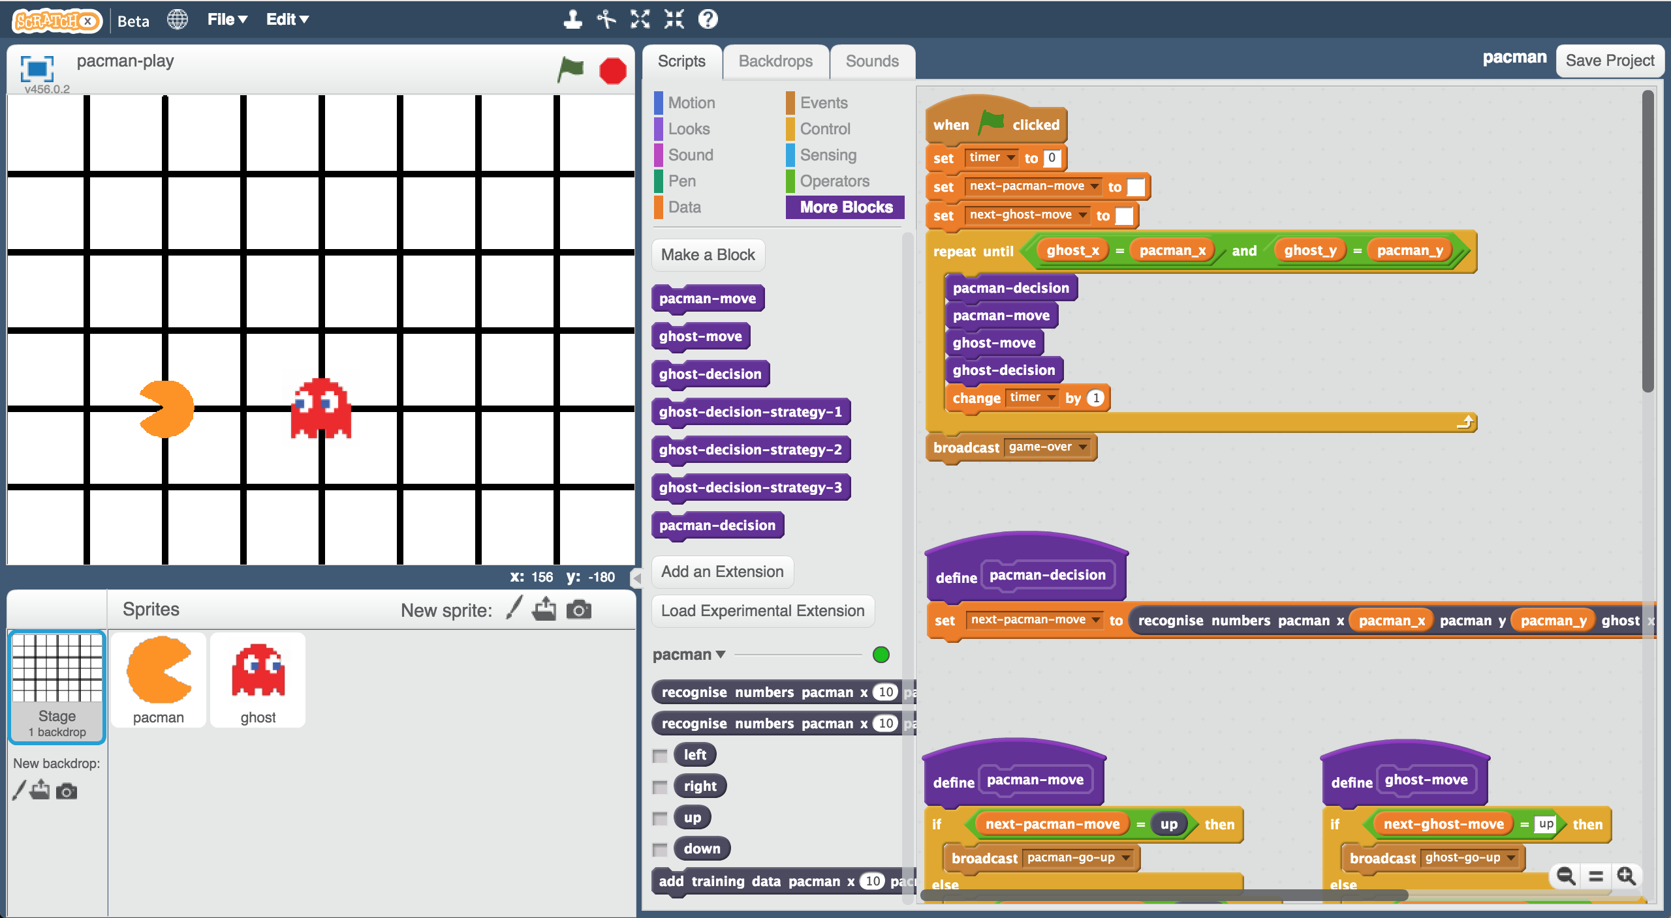

Creative Commons LicenceThis project worksheet is licensed under a Creative Commons Attribution Non-Commercial Share-Alike License

http://creativecommons.org/licenses/by-nc-sa/4.0/

1. Go to <https://machinelearningforkids.co.uk/scratchx> in a browser.
2. Open the **Pac-Man** template for this project.   
   *Click* ***Project templates*** *->* ***Pac-Man***  
   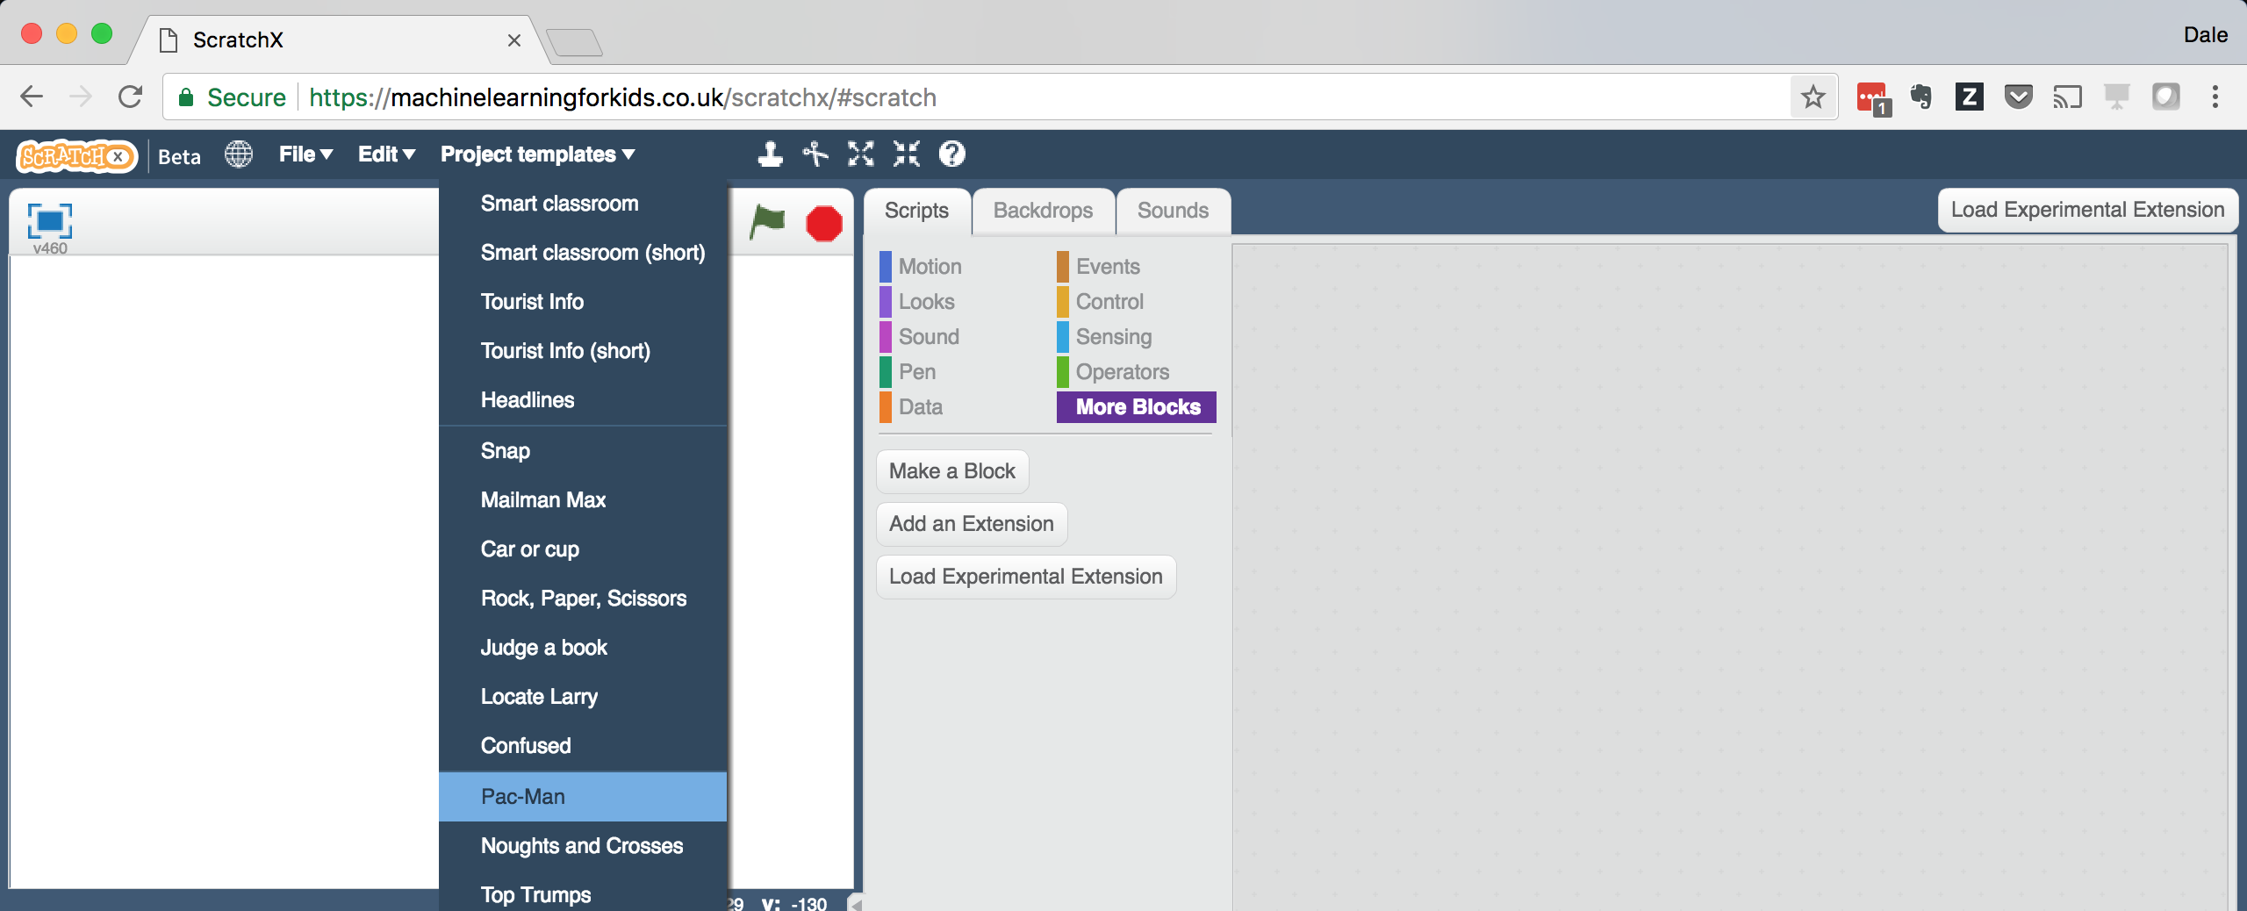
3. Click the **full-screen** button, and then click the Green Flag  
   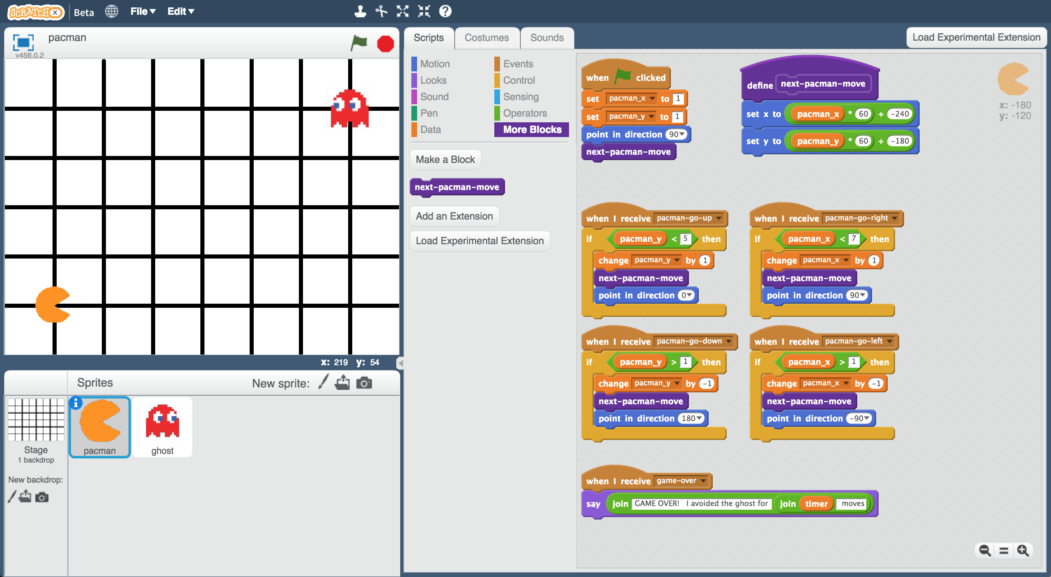
4. Play a few games of Pac-Man  
   *You control Pac-Man, and have to avoid the ghost as long as you can.   
   Use the arrow keys to control Pac-Man’s next move.*   
   *Click the green flag to start a new game.*
5. Try to come up with a plan for how Pac-Man can avoid the ghost

Representing Pac-Man in Scratch

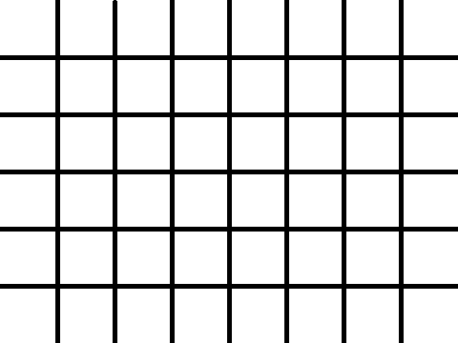

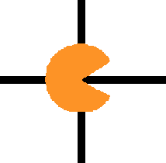

At each turn, each character has to choose between four possible moves: up, down, left, right.

There are no diagonal moves.

down

left

right

up

The game board is a graph, with both Pac-Man and the ghost only able to travel along lines.

The location of each character is stored as:

* an x-value (a number from 1 to 7)

* a y-value (a number from 1 to 5)

For example, the ghost shown on the left is at:

X = 5

Y = 2

y values

1

2

3

4

5

x values

7

6

5

4

1

2

3

**What are you going to do?**

You’re going to train Pac-Man to avoid the ghost. You’ll do this by showing it examples of how you play the game.

Imagine the board looks like this:

Imagine you decide to go down:

Imagine the board looks like this:

Imagine you decide to go up:

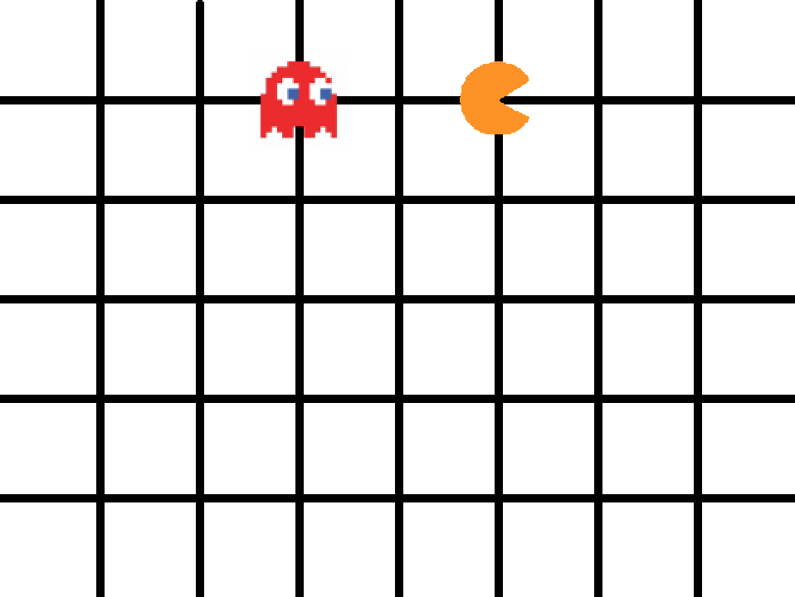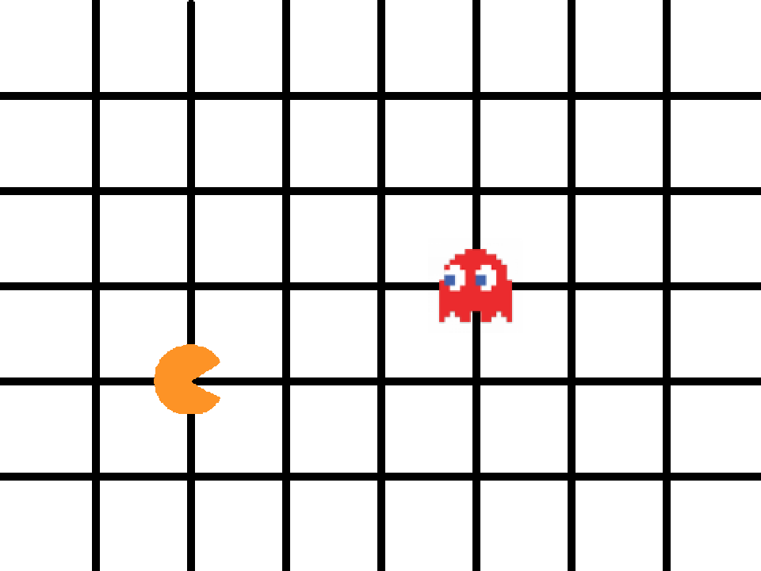

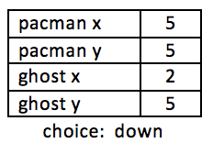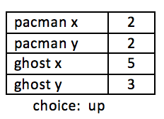

The computer will learn from the decisions that you make when you play the game.

That means if you make moves that avoid the ghost for a long time, the computer should learn how to avoid the ghost!

1. Close the Scratch window.
2. Go to <https://machinelearningforkids.co.uk/> in a web browser
3. Click on “**Get started**”
4. Click on “**Log In**” and type in your username and password  
   *If you don’t have a username, ask your teacher or group leader to create one for you.  
   If you can’t remember your username or password, ask your teacher or group leader to reset it for you.*
5. Click on “**Projects**” on the top menu bar
6. Click on the **“+ Add a new project**” button.
7. Name your project “pacman” and set it to learn how to recognise “**numbers**”  
   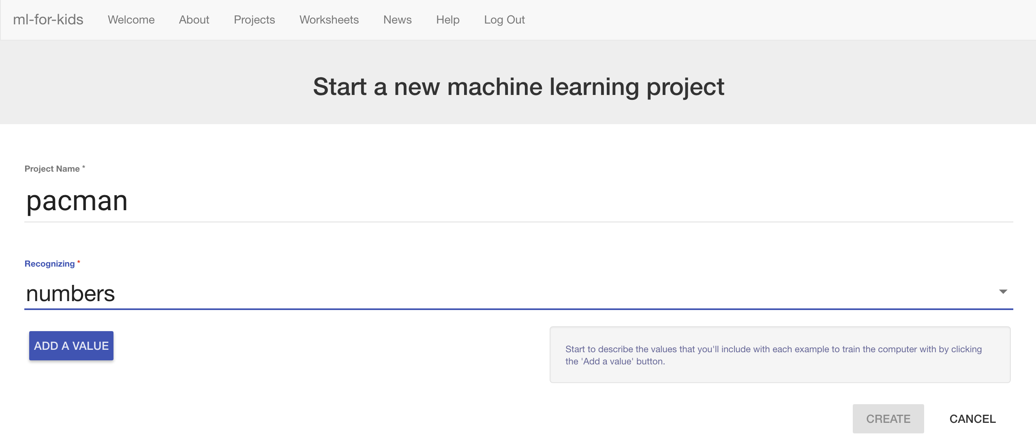
8. Click “**Add a value**” and name a value “pacman x” and make it a “number”.  
   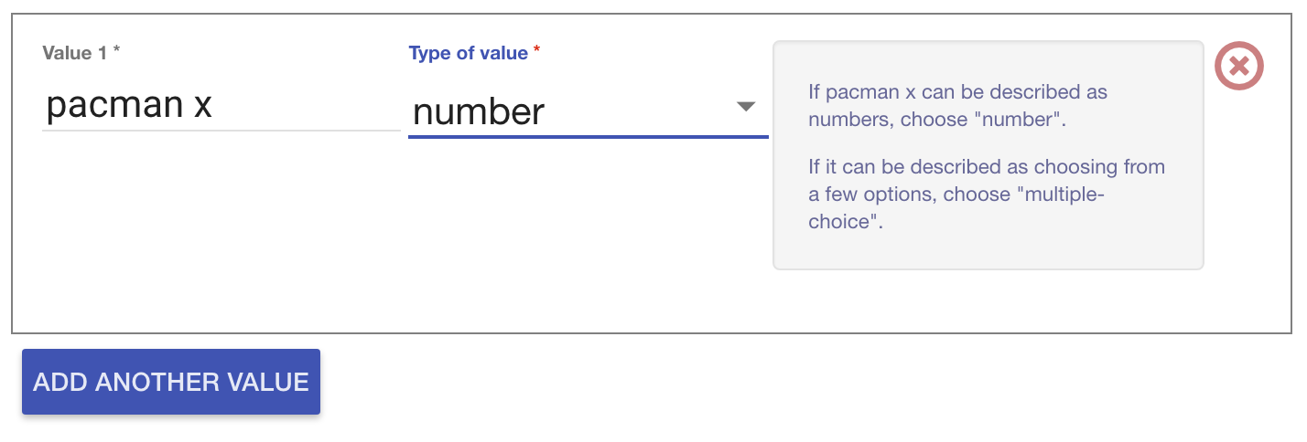
9. Click “**Add another value**” again and repeat to add values for the other three positions: “pacman y”, “ghost x”, “ghost y”  
   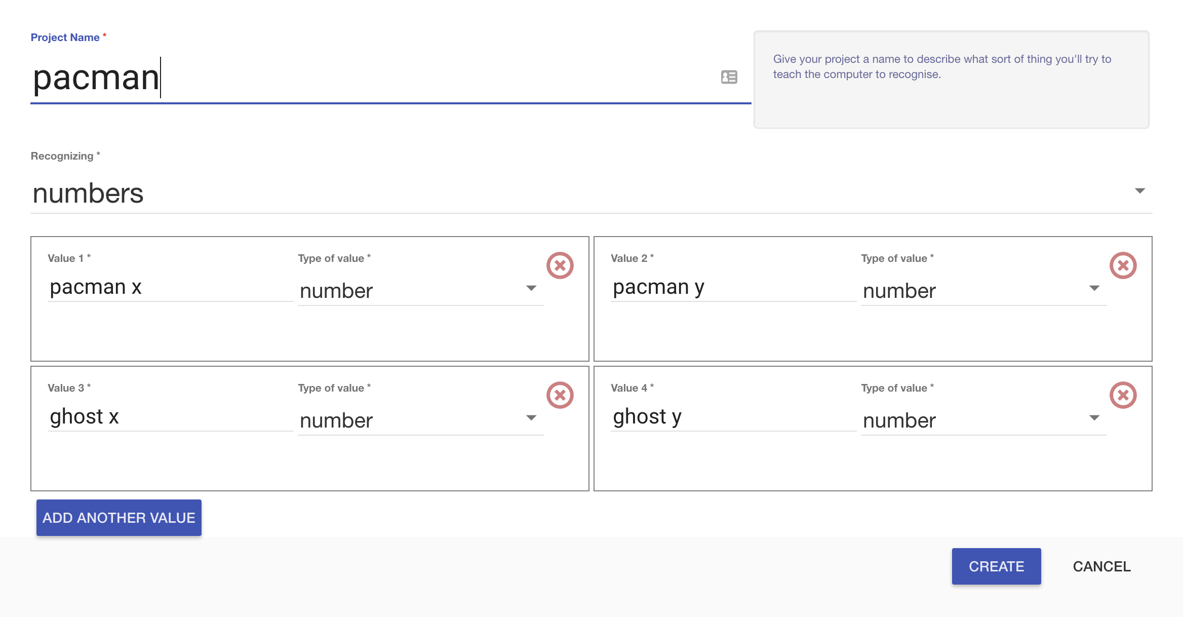
10. Click **Create**.
11. You should see “**pacman**” in the list of your projects. Click on it.  
    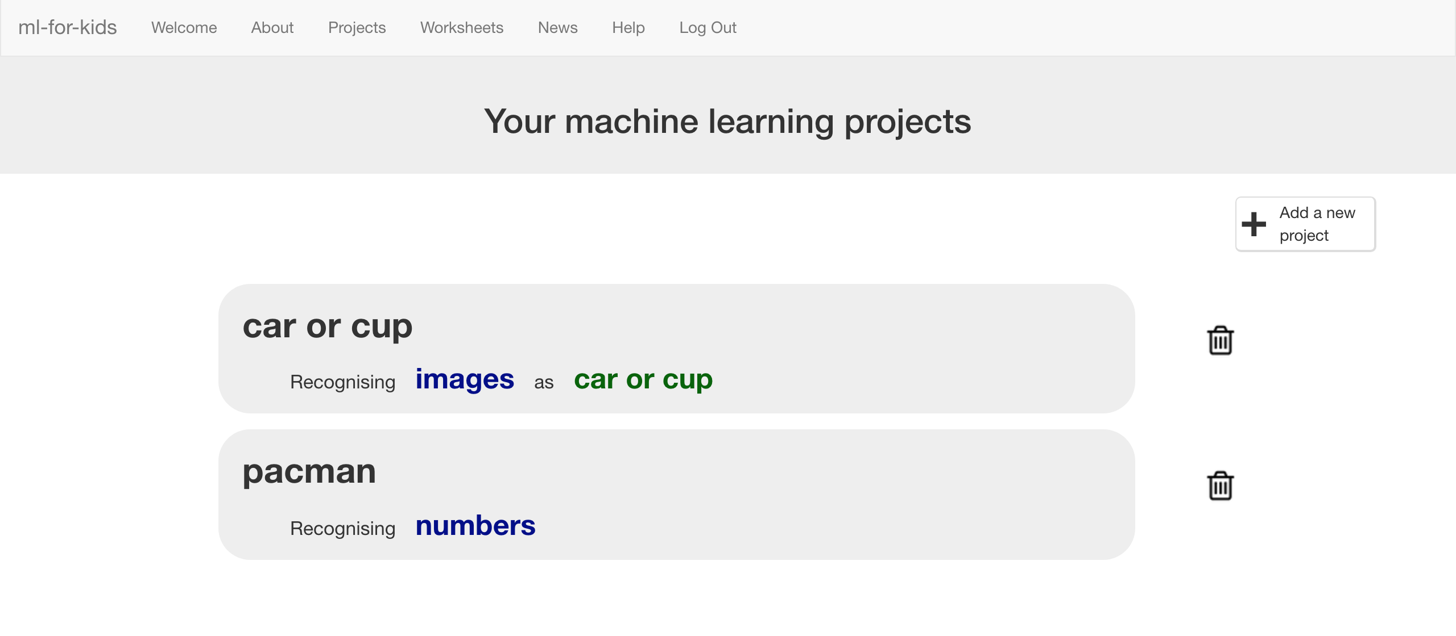
12. Click the “**Train**” button  
    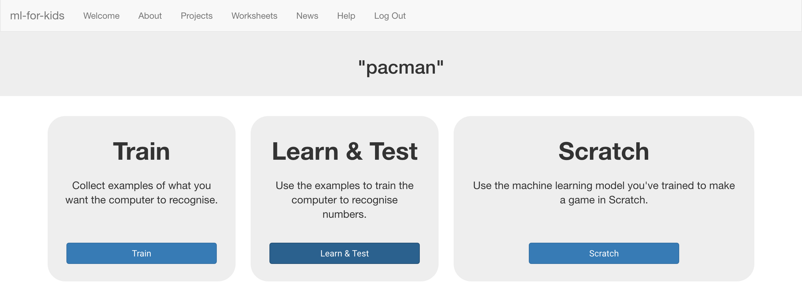
13. Click “**+ Add new label**” and create a label called “left”  
    *Examples of the locations of the Pac-Man and ghost when you go left will go in this bucket.*   
    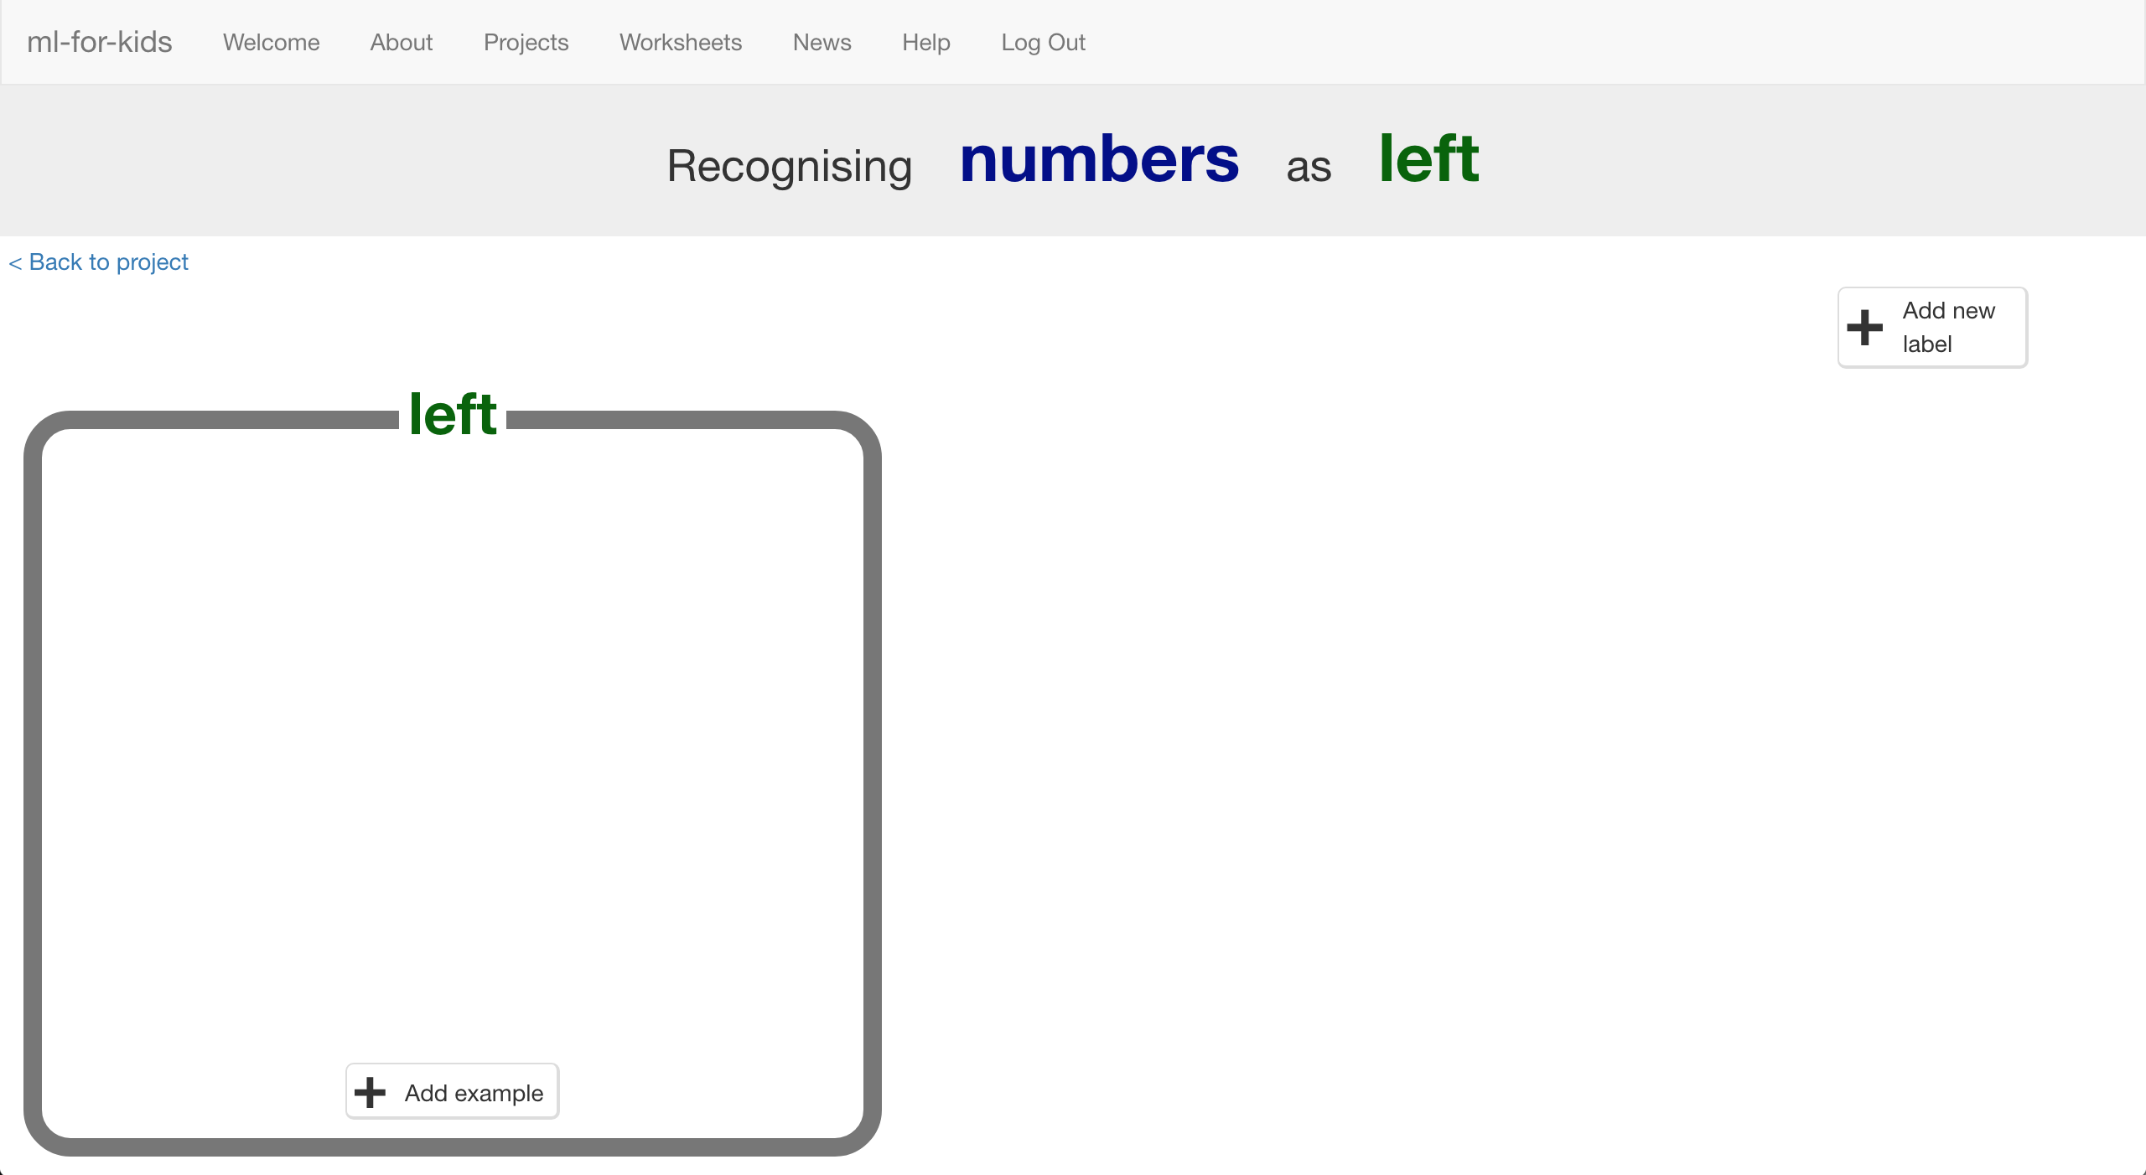

1. Click “**+ Add new label**” again and create labels for the other three moves in the game.  
   *“right”, “up”, “down”*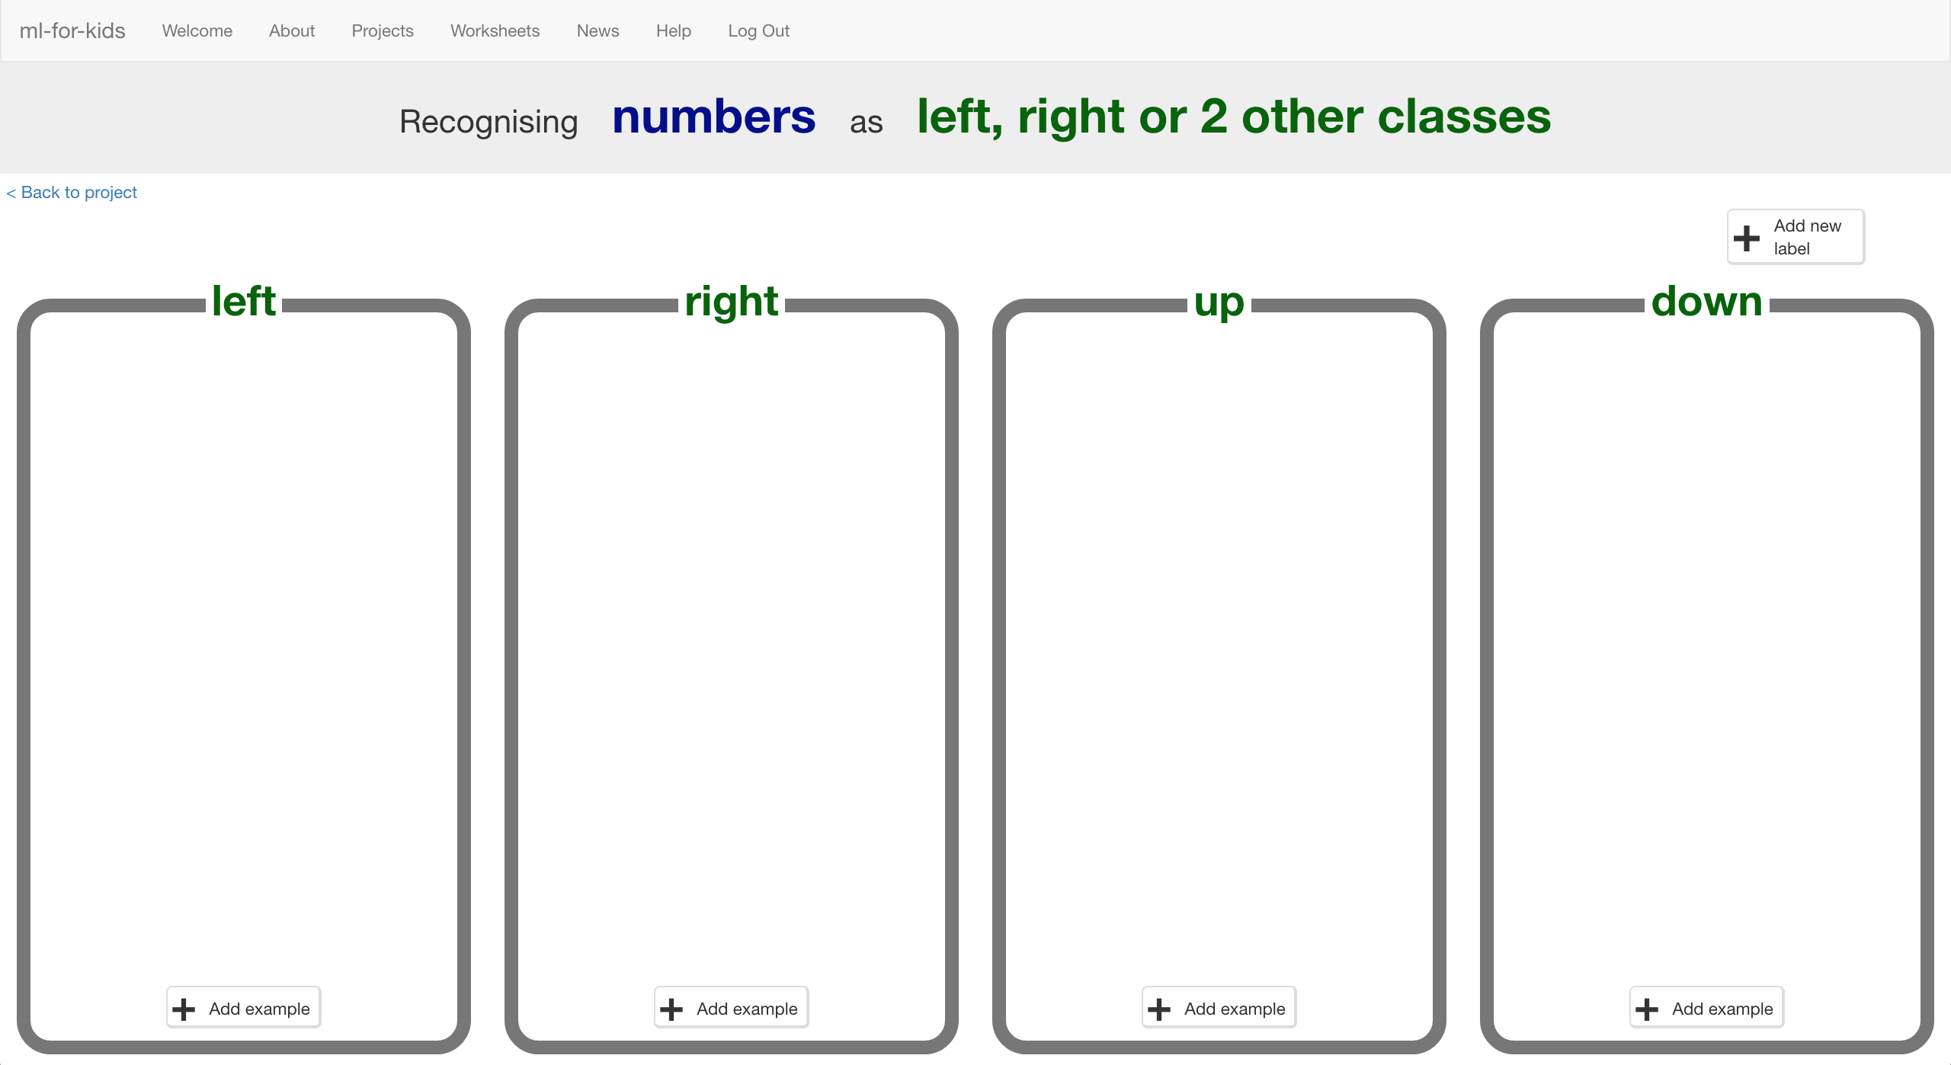
2. Click the “**< Back to project**” link then click **Scratch**
3. Click the **Open in Scratch** button  
   *It will warn you that you haven’t trained the computer yet – but that’s okay, as you’ll use Scratch to collect the training examples.   
   Click the “****go straight into Scratch now****” link.   
   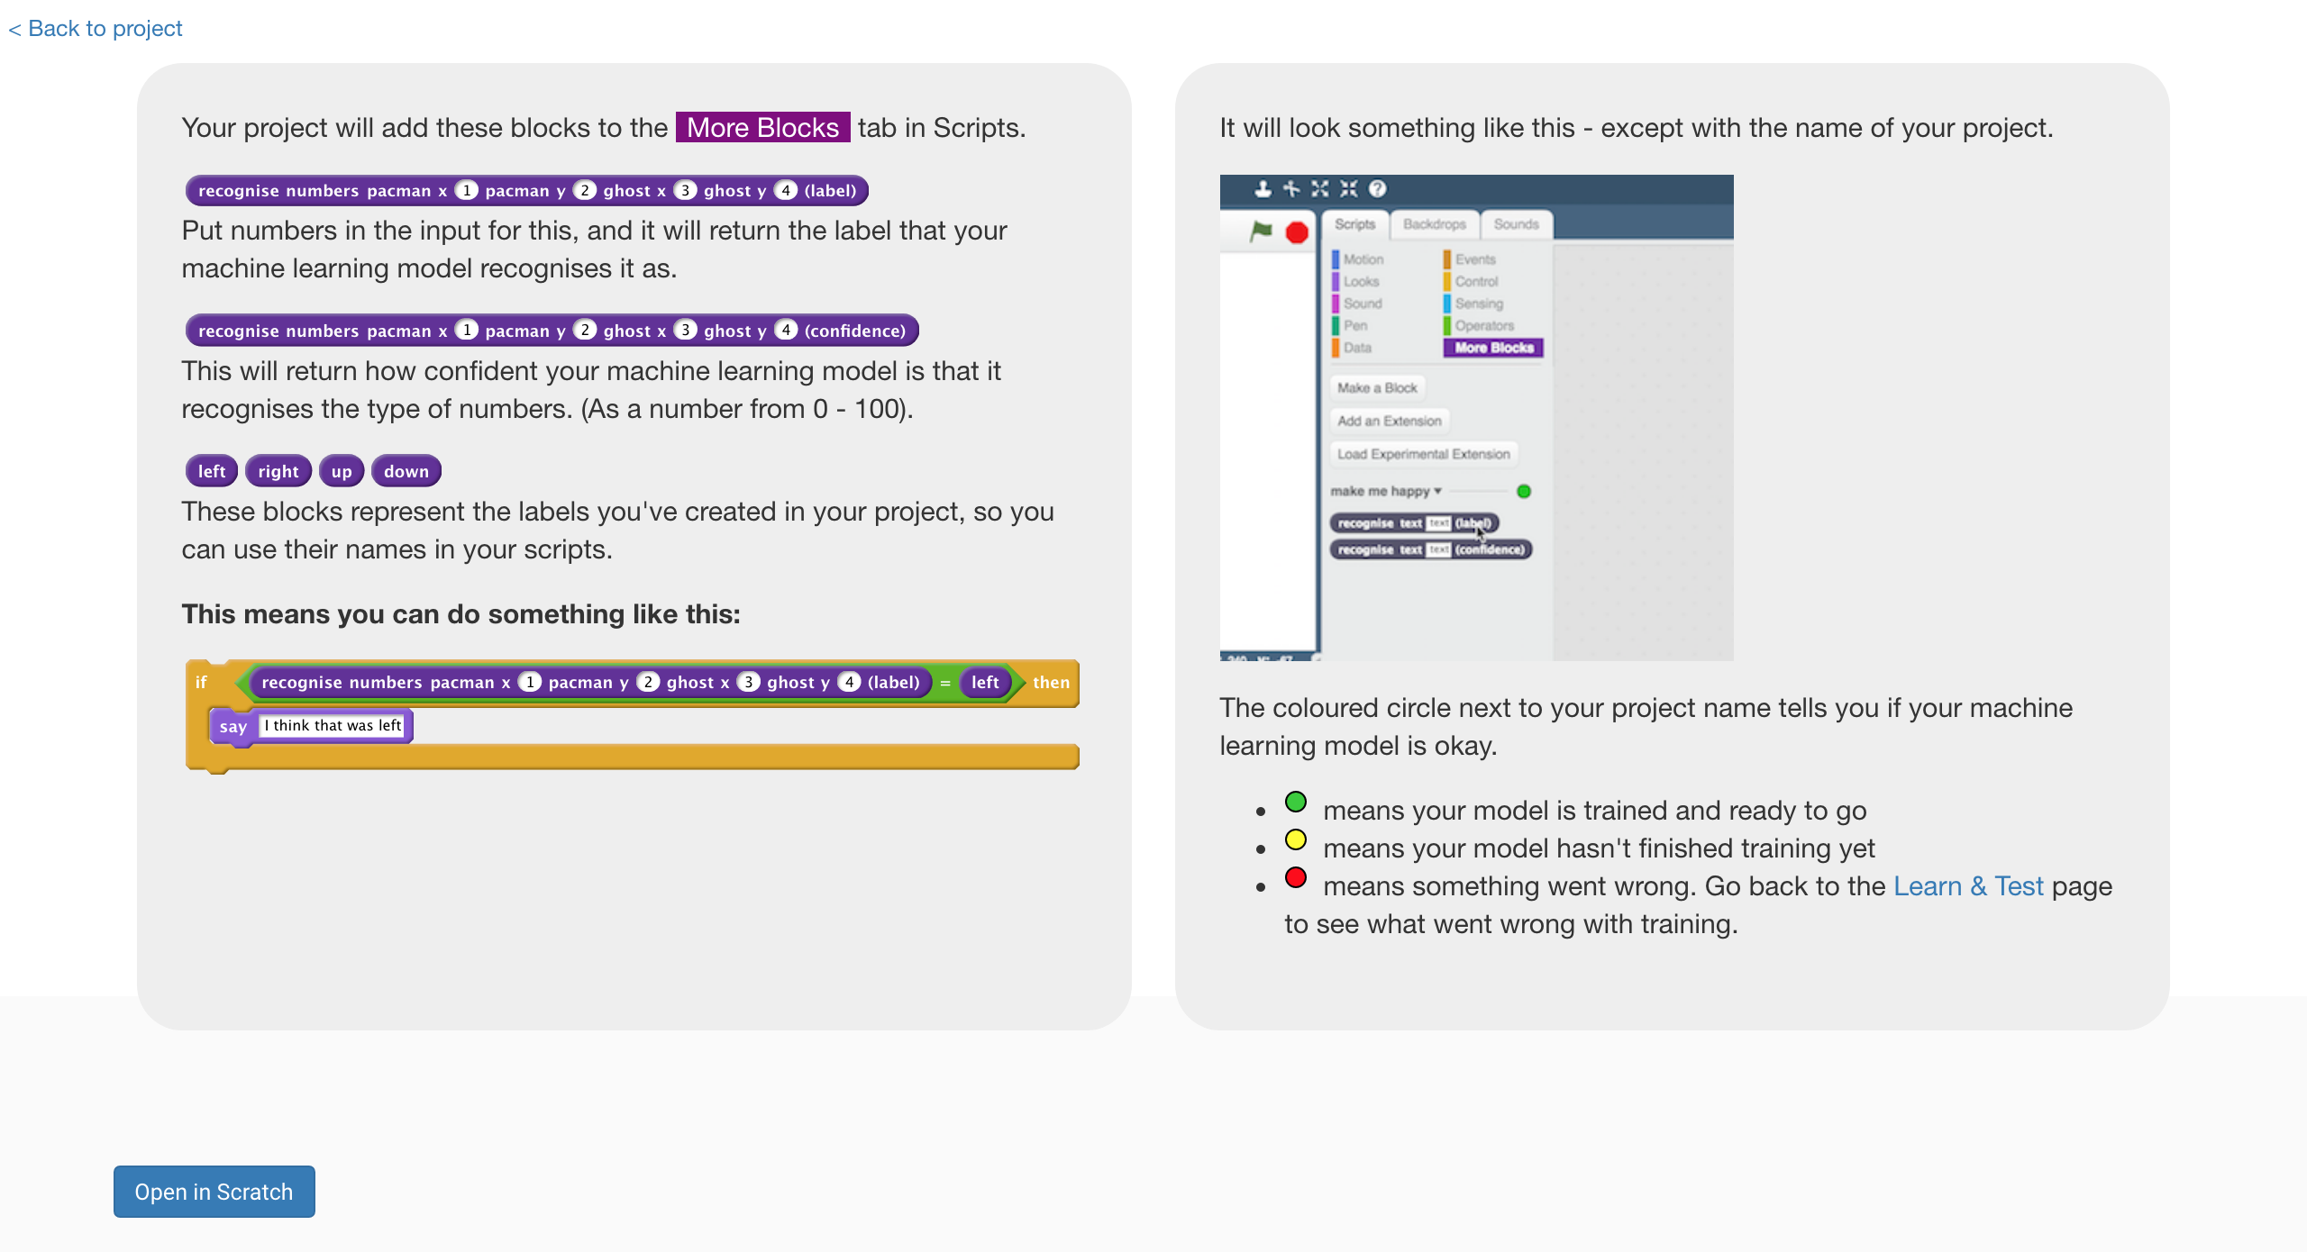*
4. You should see new blocks in the “**More blocks**” section from your “pacman” project.  
   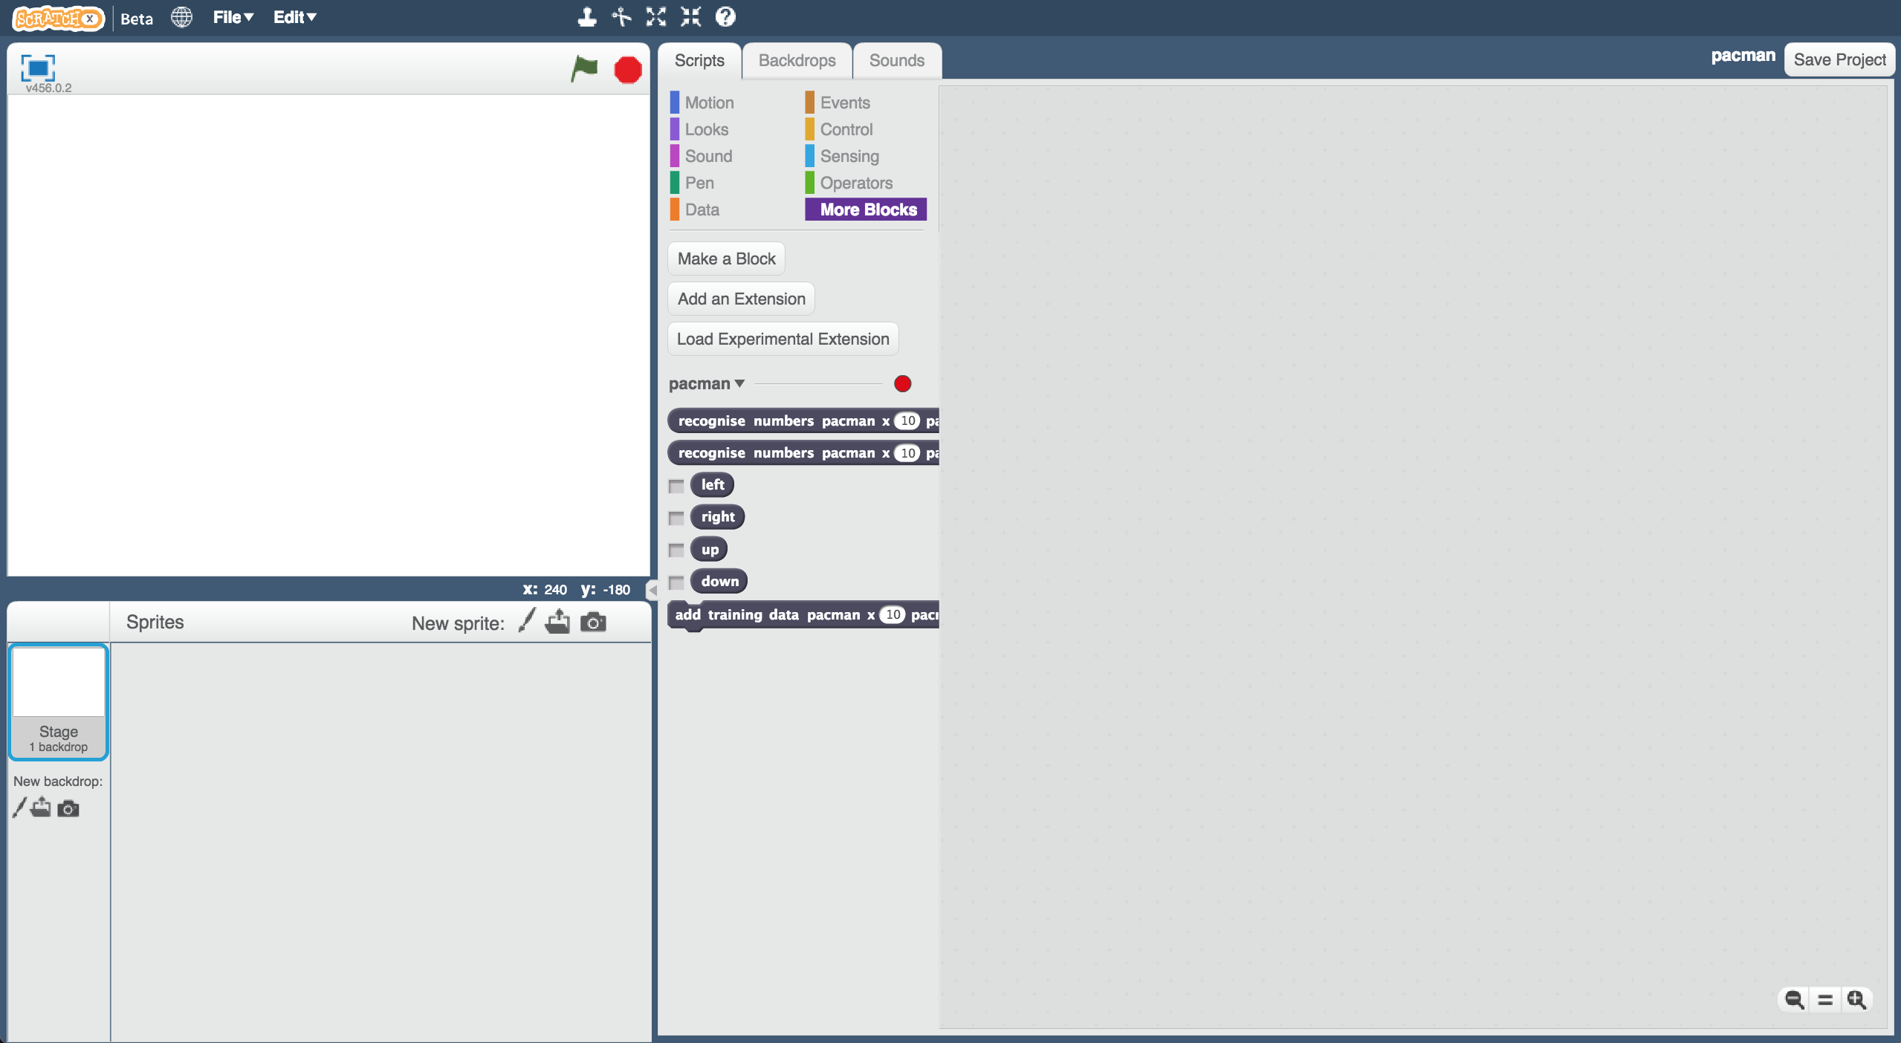
5. Open the Pac-Man template project again.  
   *Click* ***Project templates*** *->* ***Pac-Man***
6. Click on the “**Stage**”  
   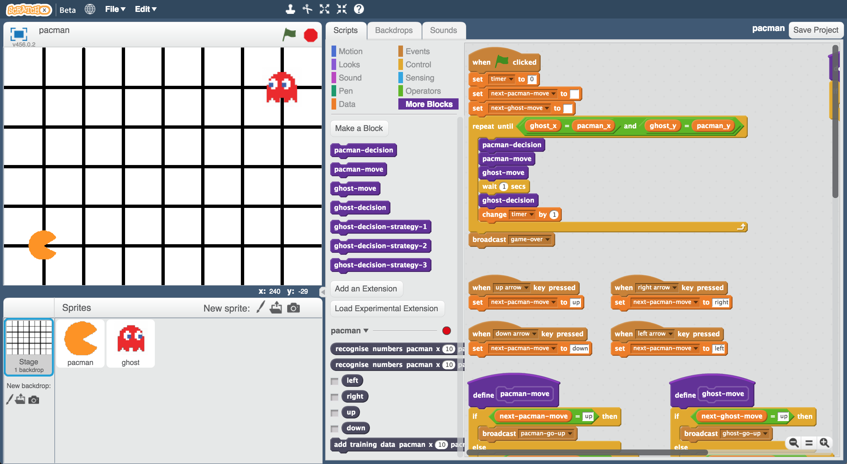
7. Modify the key press scripts to use the move choices you created  
   *Drag the “up”, “down”, “left” and “right” blocks from your “pacman” project into the boxes in the scripts like in the picture below.  
   You don’t need to add these scripts – you just need to drag in the dark blue “up”, “down”, “left”, “right” blocks from your project.  
   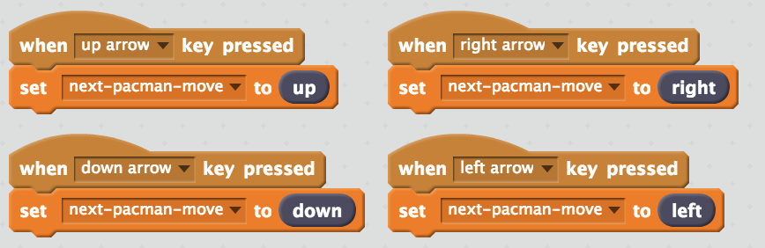*
8. Modify the custom block “**pacman-move**” to use the move choices you created  
   *Drag the “up”, “down”, “left” and “right” blocks from your “pacman” project into the boxes in the script like in the picture below.*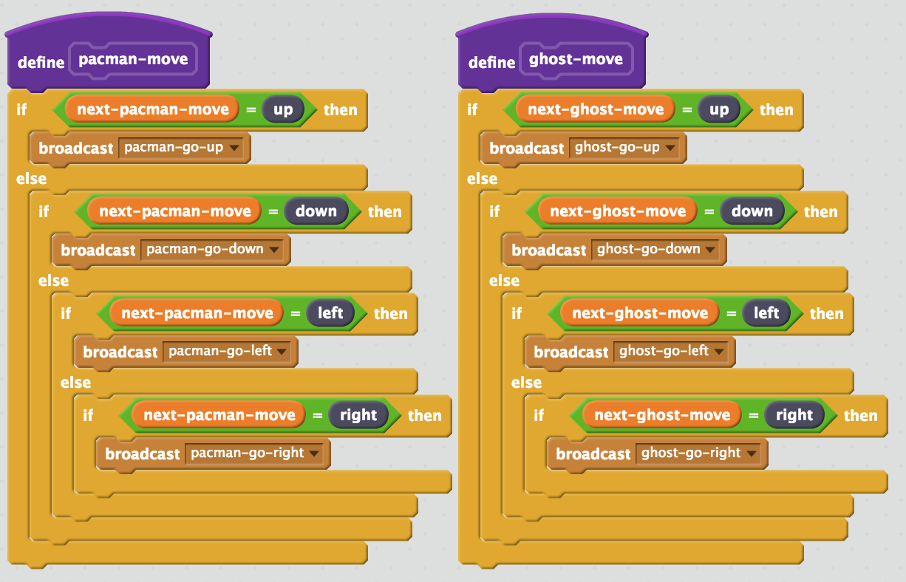
9. Update the custom block “**pacman-decision**” to add every move you make to your machine-learning training   
   *The purple “pacman-decision” block is ready for you in the starter project, at the top right of the Stage canvas.*   
   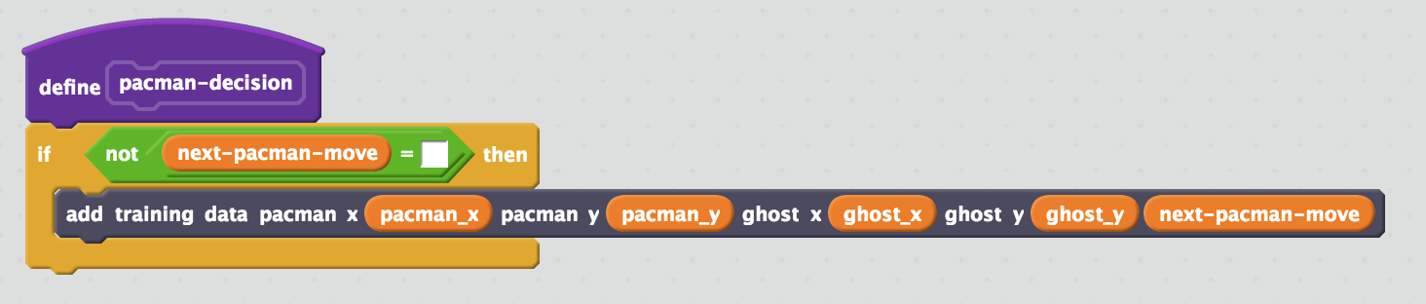
10. Train the computer!   
    *Click on full-screen again, and then the Green Flag.   
    Play a few games of Pac-Man, doing your best to avoid the ghost. The better you play, the better the computer has to learn from.*
11. Save your project  
    *Click* ***File*** *->* ***Save project*** *Name the file something like “pacman-learn.sbx” to remind yourself that this version of the project is the one to train Pac-Man.*

**What have you done so far?**

You’re teaching a computer to play Pac-Man.

So far, you updated a Scratch Pac-Man game so that it can collect examples of how you play and add them to a set of examples. And you’ll use those examples to train a machine learning “model”.

1. Go back to the training tool
2. Click the “**< Back to project**” link, then click the “**Train**” button  
   *You should see the training examples you collected by playing Pac-Man.*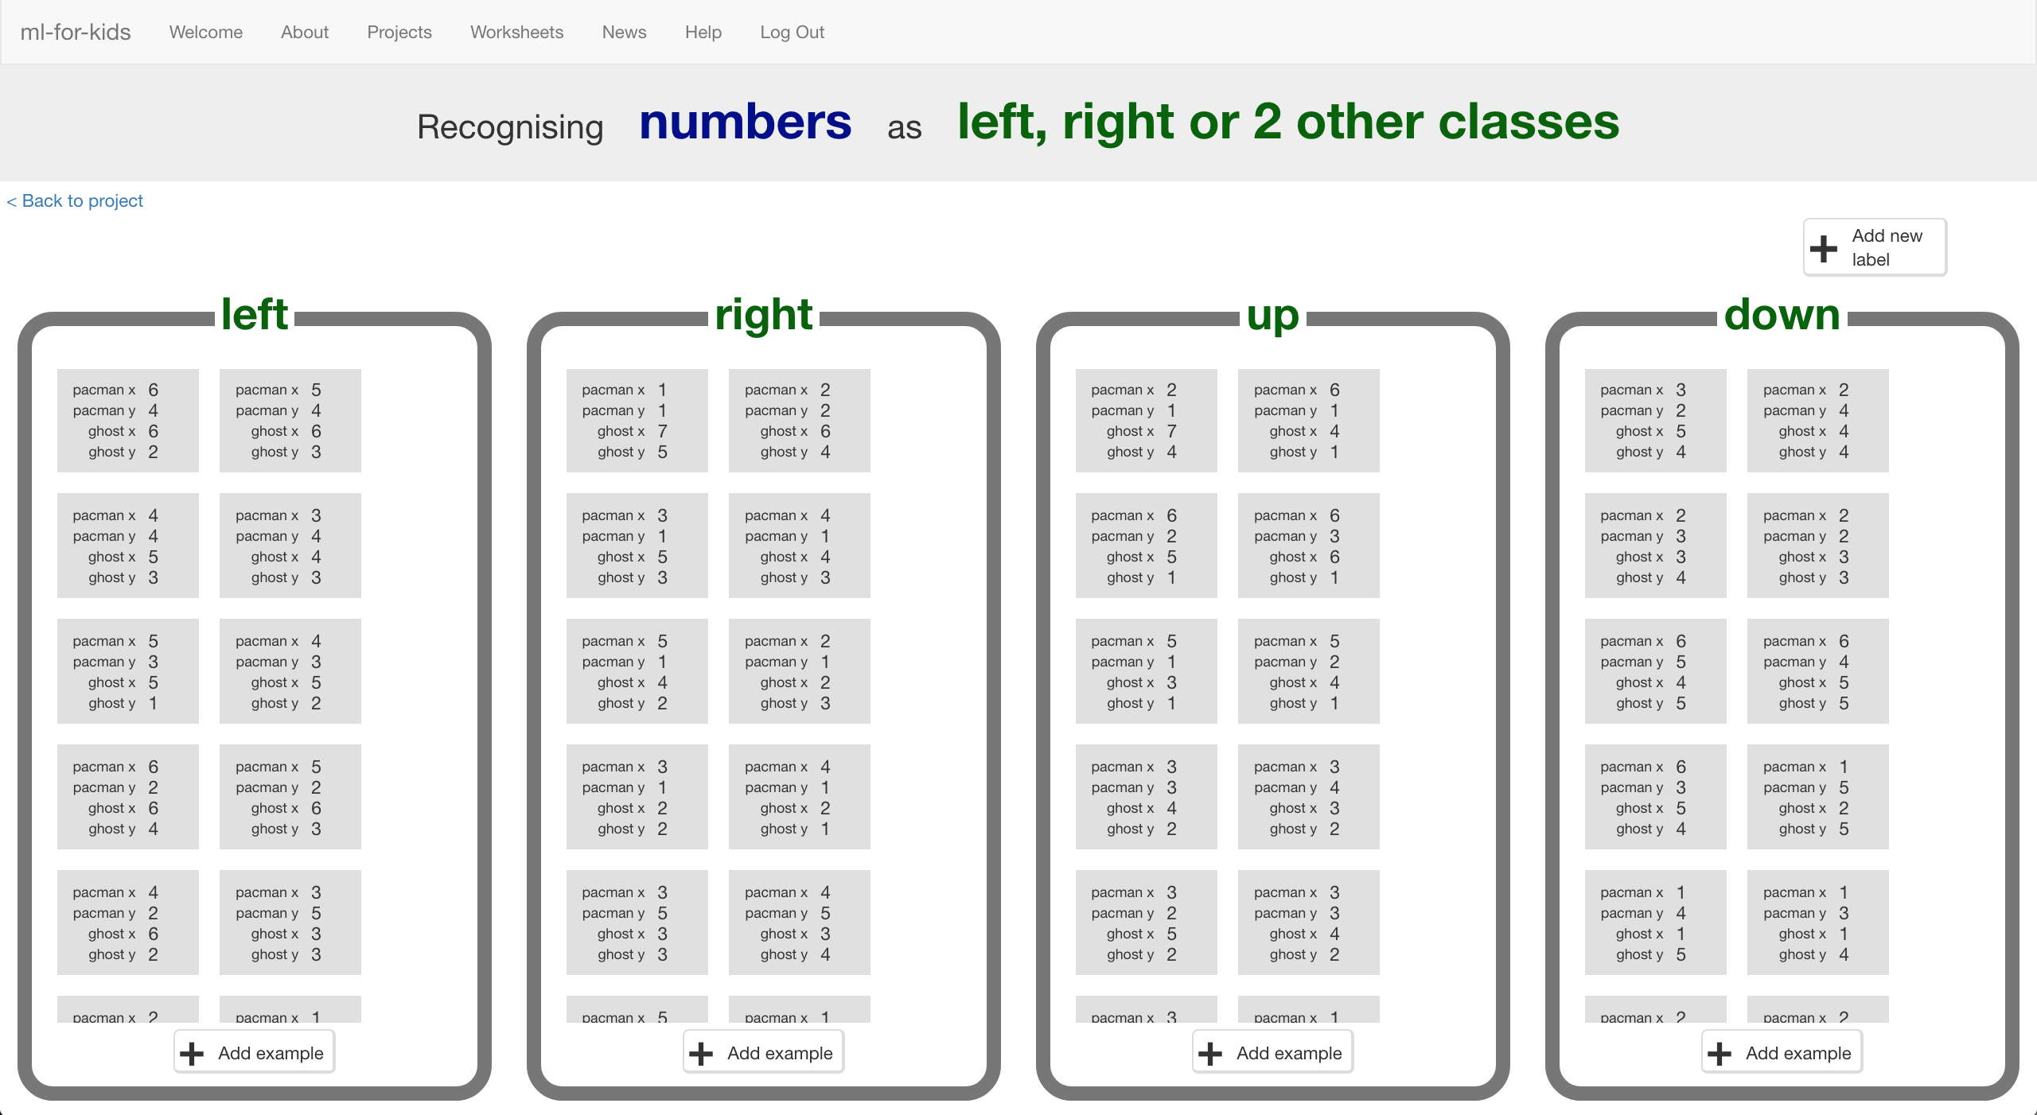
3. Click the “**< Back to project**” link, then click “**Learn & Test**”
4. Click the “**Train new machine learning model**” button  
   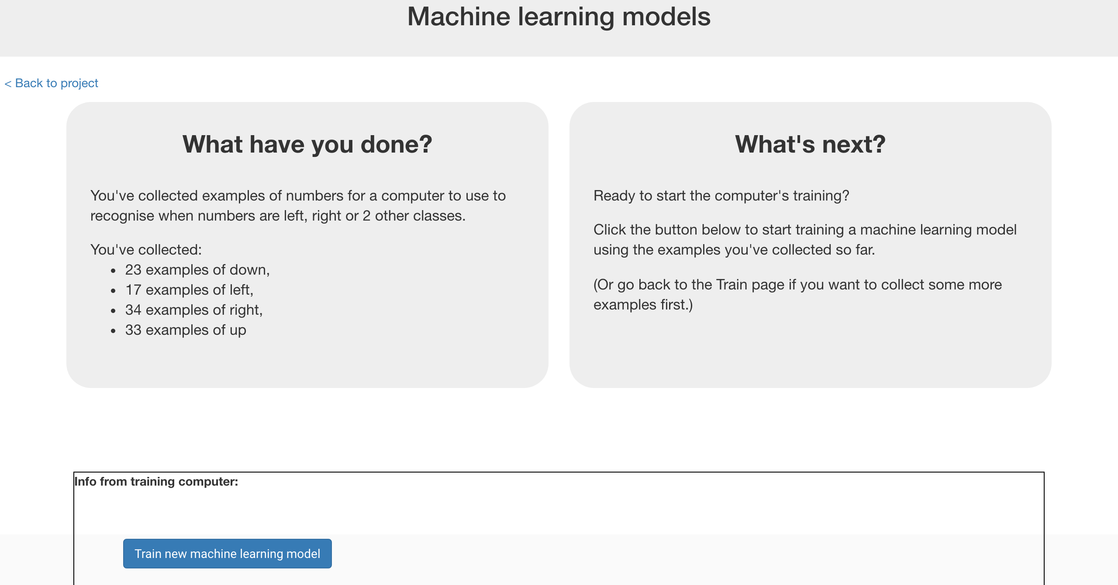
5. Switch back to the Scratch window.   
   *If you accidentally closed it, you can get back to it by doing this:  
   * Click the “****< Back to project****” link  
   * Click the “****Scratch****” button  
   * Click the “****Open in Scratch****” button  
   * Open the Scratch project you saved before, with “****File****” -> “****Load Project****”*
6. Click on the Stage  
   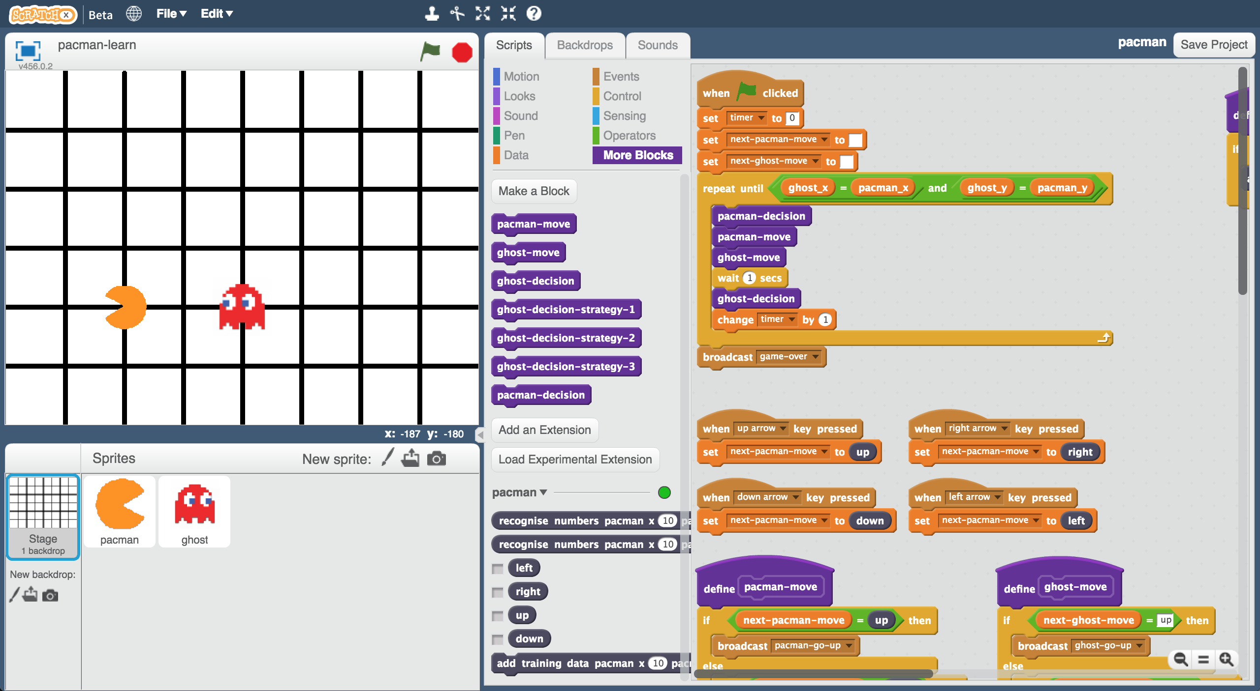
7. Delete the key press scripts because it’s the computer’s turn!  
   *(Delete a script by dragging it back onto the palette, or right-click and choose “Delete”)  
   These are the scripts you don’t need any more:  
   *
8. Modify the custom “**pacman-decision**” block  
   *Instead of learning from what you are doing, now you want to use your machine learning model*  
   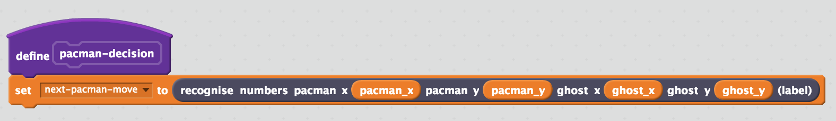
9. Modify the “Click Green Flag” script to remove “wait 1 second”. *You want the script to end up looking like this:  
   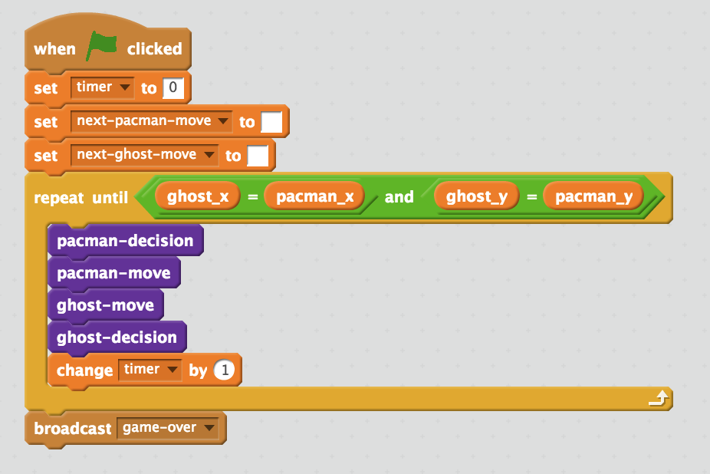*
10. Save your project  
    *Click* ***File*** *->* ***Save project*** *Name the file something like “pacman-play.sbx” to remind yourself that this version of the project is where the computer controls Pac-Man.*
11. Test the computer!  
    *Click on full-screen again, and then the Green Flag.   
    Watch the Pac-Man you’ve trained try to avoid the ghost.*
12. Open the training project “**pacman-learn.sbx**”.  
    *Make sure you save your pacman-play project first!  
    Click* ***File*** *->* ***Load Project***
13. Train the computer some more by playing a few more games.
14. Go back to the training tool
15. Go back to the “Learn & Test” page  
    *Click the “****< Back to project****” link, and then click “****Learn & Test****”*
16. Click the “**Train new machine learning model**” button again
17. Switch back to the Scratch window.   
    *If you accidentally closed it, you can get back to it by doing this:  
    * Click the “****< Back to project****” link  
    * Click the “****Scratch****” button  
    * Click the “****Open in Scratch****” button*
18. Open the testing project “**pacman-play.sbx**”  
    *Click* ***File*** *->* ***Load Project***
19. Test the computer again  
    *Did the computer do any better after more training?*

**Tips**

**Getting stuck in a loop**

Sometimes the computer can get lucky, and find a circular route around the board that gets into a never-ending loop.

When this happens, Pac-Man will never lose!

You can press the red stop button if you need to stop though.

**Keep training**

The more examples the computer has to learn from, the better it will get. If you have time, play a lot of games and train a new model again.

**Don’t be kind!**

You might be tempted to go easy on the ghost when you’re playing against it.

Don’t. It is learning from the way that you play. If you don’t complete a three-in-a-row when you can, you will be teaching it that it should do that.

If you want it to get better quickly, **play as well as you can**.

**What have you done?**

You’ve trained a computer to play Pac-Man.

You didn’t have to describe the rules to the computer.

You didn’t tell it that it should try to avoid the ghost.

You didn’t describe the boundaries of the board.

(The rules are in the Scratch game, but that doesn’t count – that wasn’t used in the machine learning model).

Instead, you showed it how you play, by collecting examples of decisions that you made when you play.

**Ideas and Extensions**

Now that you’ve finished, why not give one of these ideas a try?

Or come up with one of your own?

**Add another ghost**

The game is beatable with only one ghost – Pac-Man can just carry on avoiding the ghost forever.

But with a second ghost chasing after Pac-Man, it will get really hard.

**Change the game board**

Try making the game board bigger.

Or add obstacles that Pac-Man and the ghost will need to go around.